Key points
- DNA sequencing is the process of determining the sequence of nucleotides (As, Ts, Cs, and Gs) in a piece of DNA.
- In Sanger sequencing, the target DNA is copied many times, making fragments of different lengths. Fluorescent “chain terminator” nucleotides mark the ends of the fragments and allow the sequence to be determined.
- Next-generation sequencing techniques are new, large-scale approaches that increase the speed and reduce the cost of DNA sequencing.
What is sequencing?
You may have heard of genomes being sequenced. For instance, the human genome was completed in 2003, after a many-year, international effort. But what does it mean to sequence a genome, or even a small fragment of DNA?
DNA sequencing is the process of determining the sequence of nucleotide bases (As, Ts, Cs, and Gs) in a piece of DNA. Today, with the right equipment and materials, sequencing a short piece of DNA is relatively straightforward.
Sequencing an entire genome (all of an organism’s DNA) remains a complex task. It requires breaking the DNA of the genome into many smaller pieces, sequencing the pieces, and assembling the sequences into a single long "consensus." However, thanks to new methods that have been developed over the past two decades, genome sequencing is now much faster and less expensive than it was during the Human Genome Project^11start superscript, 1, end superscript.
In this article, we’ll take a look at methods used for DNA sequencing. We'll focus on one well-established method, Sanger sequencing, but we'll also discuss new ("next-generation") methods that have reduced the cost and accelerated the speed of large-scale sequencing.

Sanger sequencing:(The chain termination method)
Regions of DNA up to about 900900900 base pairs in length are routinely sequenced using a method called Sanger sequencing or the chain termination method. Sanger sequencing was developed by the British biochemist Fred Sanger and his colleagues in 1977.
In the Human Genome Project, Sanger sequencing was used to determine the sequences of many relatively small fragments of human DNA. (These fragments weren't necessarily 900900900 bp or less, but researchers were able to "walk" along each fragment using multiple rounds of Sanger sequencing.) The fragments were aligned based on overlapping portions to assemble the sequences of larger regions of DNA and, eventually, entire chromosomes.
Although genomes are now typically sequenced using other methods that are faster and less expensive, Sanger sequencing is still in wide use for the sequencing of individual pieces of DNA, such as fragments used in DNA cloning or generated through polymerase chain reaction (PCR).
Ingredients for Sanger sequencing
Sanger sequencing involves making many copies of a target DNA region. Its ingredients are similar to those needed for DNA replication in an organism, or for polymerase chain reaction (PCR), which copies DNA in vitro. They include:
- A DNA polymerase enzyme
- A primer, which is a short piece of single-stranded DNA that binds to the template DNA and acts as a "starter" for the polymerase
- The four DNA nucleotides (dATP, dTTP, dCTP, dGTP)
- The template DNA to be sequenced
However, a Sanger sequencing reaction also contains a unique ingredient:
- Dideoxy, or chain-terminating, versions of all four nucleotides (ddATP, ddTTP, ddCTP, ddGTP), each labeled with a different color of dye
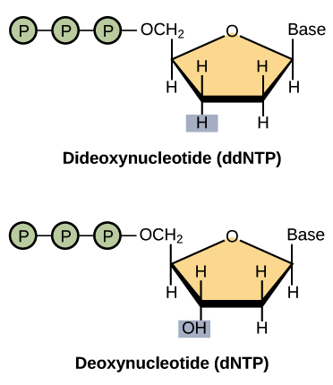
Dideoxy nucleotides are similar to regular, or deoxy, nucleotides, but with one key difference: they lack a hydroxyl group on the 3’ carbon of the sugar ring. In a regular nucleotide, the 3’ hydroxyl group acts as a “hook," allowing a new nucleotide to be added to an existing chain.
Once a dideoxy nucleotide has been added to the chain, there is no hydroxyl available and no further nucleotides can be added. The chain ends with the dideoxy nucleotide, which is marked with a particular color of dye depending on the base (A, T, C or G) that it carries.
Method of Sanger sequencing
The DNA sample to be sequenced is combined in a tube with primer, DNA polymerase, and DNA nucleotides (dATP, dTTP, dGTP, and dCTP). The four dye-labeled, chain-terminating dideoxy nucleotides are added as well, but in much smaller amounts than the ordinary nucleotides.
The mixture is first heated to denature the template DNA (separate the strands), then cooled so that the primer can bind to the single-stranded template. Once the primer has bound, the temperature is raised again, allowing DNA polymerase to synthesize new DNA starting from the primer. DNA polymerase will continue adding nucleotides to the chain until it happens to add a dideoxy nucleotide instead of a normal one. At that point, no further nucleotides can be added, so the strand will end with the dideoxy nucleotide.
This process is repeated in a number of cycles. By the time the cycling is complete, it’s virtually guaranteed that a dideoxy nucleotide will have been incorporated at every single position of the target DNA in at least one reaction. That is, the tube will contain fragments of different lengths, ending at each of the nucleotide positions in the original DNA (see figure below). The ends of the fragments will be labeled with dyes that indicate their final nucleotide.
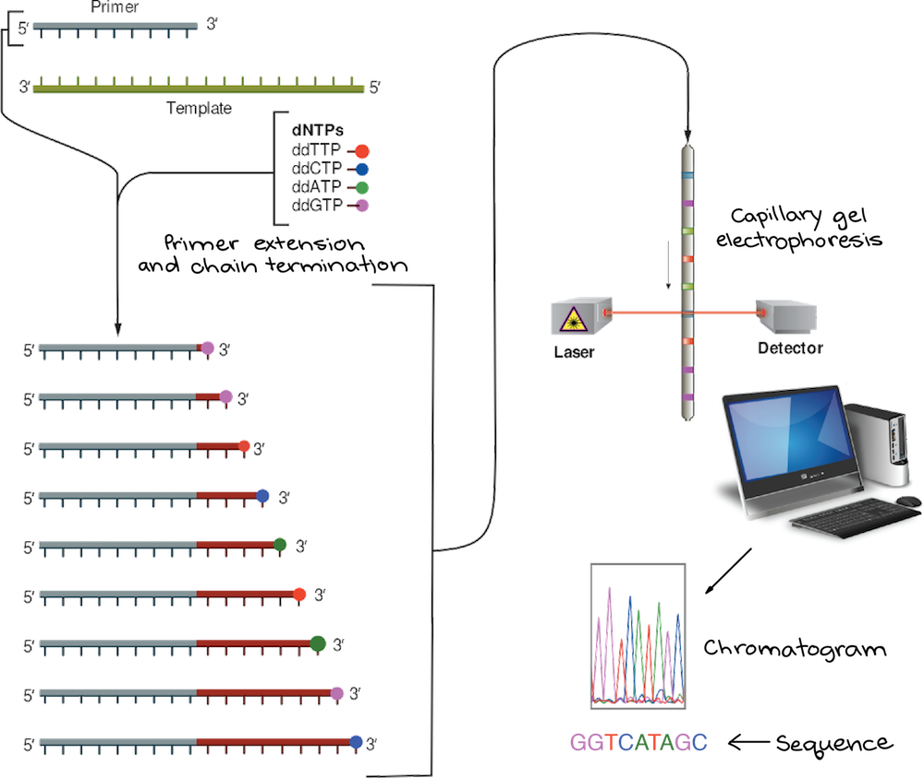

After the reaction is done, the fragments are run through a long, thin tube containing a gel matrix in a process called capillary gel electrophoresis. Short fragments move quickly through the pores of the gel, while long fragments move more slowly. As each fragment crosses the “finish line” at the end of the tube, it’s illuminated by a laser, allowing the attached dye to be detected.
The smallest fragment (ending just one nucleotide after the primer) crosses the finish line first, followed by the next-smallest fragment (ending two nucleotides after the primer), and so forth. Thus, from the colors of dyes registered one after another on the detector, the sequence of the original piece of DNA can be built up one nucleotide at a time. The data recorded by the detector consist of a series of peaks in fluorescence intensity, as shown in the chromatogram above. The DNA sequence is read from the peaks in the chromatogram.
Uses and limitations
Sanger sequencing gives high-quality sequence for relatively long stretches of DNA (up to about 900900900 base pairs). It's typically used to sequence individual pieces of DNA, such as bacterial plasmids or DNA copied in PCR.
However, Sanger sequencing is expensive and inefficient for larger-scale projects, such as the sequencing of an entire genome or metagenome (the “collective genome” of a microbial community). For tasks such as these, new, large-scale sequencing techniques are faster and less expensive.
Next-generation sequencing
The name may sound like Star Trek, but that’s really what it’s called! The most recent set of DNA sequencing technologies are collectively referred to as next-generation sequencing.
There are a variety of next-generation sequencing techniques that use different technologies. However, most share a common set of features that distinguish them from Sanger sequencing:
- Highly parallel: many sequencing reactions take place at the same time
- Micro scale: reactions are tiny and many can be done at once on a chip
- Fast: because reactions are done in parallel, results are ready much faster
- Low-cost: sequencing a genome is cheaper than with Sanger sequencing
- Shorter length: reads typically range from 505050 -700700700 nucleotides in length
Conceptually, next-generation sequencing is kind of like running a very large number of tiny Sanger sequencing reactions in parallel. Thanks to this parallelization and small scale, large quantities of DNA can be sequenced much more quickly and cheaply with next-generation methods than with Sanger sequencing. For example, in 2001, the cost of sequencing a human genome was almost \$100$100dollar sign, 100 \text{million}millionstart text, m, i, l, l, i, o, n, end text. In 2015, it was just \$1245$1245dollar sign, 1245^22squared!
Why does fast and inexpensive sequencing matter? The ability to routinely sequence genomes opens new possibilities for biology research and biomedical applications. For example, low-cost sequencing is a step towards personalized medicine – that is, medical treatment tailored to an individual's needs, based on the gene variants in his or her genome

